**CSE 322: Computer Networks Sessional**

**Report on Network Simulator 2 (NS2) Offline**

# Department of Computer Science and Engineering

# Bangladesh University of Engineering and Technology

**Somonindro Roy**

**ID : 1805049**

**Section : A**

**MAC type : Wireless MAC 802.15.4**

IEEE 802.15.4 is a technical standard which defines the operation of a low-rate wireless personal area network (LR-WPAN). It specifies the physical layer and media access control for LR-WPANs. It intends to offer the fundamental lower network layers of a type of wireless personal area network (WPAN) which focuses on low-cost, low-speed ubiquitous communication between devices. It can be contrasted with other approaches, such a Wi-Fi, which offer more bandwidth and requires more power. The emphasis is on very low cost communication of nearby devices with little to no underlying infrastructure, intending to exploit this to lower power consumption even more.

Key 802.15.4 features include:

1. Real time suitability by reservation of Guaranteed Time Slots (GTS).
2. collision avoidance through CSMA/CA.
3. integrated support for secure communications.
4. power management functions such as link speed/quality and energy detection.
5. Support for time and data rate sensitive applications because of its ability to operate either as CSMA/CA or TDMA access modes. The TDMA mode of operation is supported via the GTS feature of the standard.
6. IEEE 802.15.4-conformant devices may use one of three possible frequency bands for operation (868/915/2450 MHz).

**Routing protocol : DSR (Dynamic Source Routing)**

Dynamic Source Routing (DSR) is a routing protocol for wireless mesh network. It is similar to AODV in that it forms a route on-demand when a transmitting node requests one. However, it uses source routing instead of relying on the routing table at each intermediate device. To avoid using source routing, DSR optionally defines a flow id option that allows packets to be forwarded on a hop-by-hop basis.

This protocol is truly based on source routing whereby all the routing information is maintained (continually updated) at mobile nodes. It has only two major phases, which are Route Discovery and Route Maintenance. Route Reply would only be generated if the message has reached the intended destination node (route record which is initially contained in Route Request would be inserted into the Route Reply).

**Agent type : TCP Reno**

TCP (Transmission Control Protocol) is known as a connection-oriented protocol, which ensures reliability, and is also responsible for congestion control mechanisms in the network. TCP Reno is a technique of [TCP congestion control](https://www.geeksforgeeks.org/tcp-congestion-control/), this is used when the sender receives three duplicate acknowledgments. TCP Reno is an extension of [TCP Tahoe](https://www.geeksforgeeks.org/tcp-tahoe-and-tcp-reno/) (the first in-built congestion control algorithm).

**Aplication type : FTP**

The File Transfer Protocol (FTP) is a standard [communication protocol](https://en.wikipedia.org/wiki/Communication_protocol) used for the transfer of [computer files](https://en.wikipedia.org/wiki/Computer_file) from a server to a client on a [computer network](https://en.wikipedia.org/wiki/Computer_network). FTP is built on a [client-server model](https://en.wikipedia.org/wiki/Client%E2%80%93server_model) architecture using separate control and data connections between the client and the server. FTP users may authenticate themselves with a [clear-text](https://en.wikipedia.org/wiki/Clear_text) sign-in protocol, normally in the form of a username and password, but can connect anonymously if the server is configured to allow it. For secure transmission that protects the username and password, and encrypts the content, FTP is often [secured](https://en.wikipedia.org/wiki/File_Transfer_Protocol#Security) with [SSL/TLS](https://en.wikipedia.org/wiki/Transport_Layer_Security) ([FTPS](https://en.wikipedia.org/wiki/FTPS)) or replaced with [SSH File Transfer Protocol](https://en.wikipedia.org/wiki/SSH_File_Transfer_Protocol) (SFTP).

**Varying area size :** (taking 5 samples for each case)

Number of Nodes = 40 and Number of Flows = 20

|  |  |  |  |  |  |  |  |
| --- | --- | --- | --- | --- | --- | --- | --- |
| Area  Size | Sent  Packets | Dropped Packets | Received Packets | Throughput  (bits/sec) | Average Delay (sec) | Delivery ratio | Drop ratio |
| 250 | 682 | 195 | 488 | 1565.44 | 0.296821 | 0.715543 | 0.285924 |
| 119 | 105 | 14 | 44.8 | 0.651624 | 0.117647 | 0.882353 |
| 110 | 101 | 9 | 28.8 | 0.668188 | 0.0818182 | 0.918182 |
| 106 | 99 | 7 | 22.4 | 0.84193 | 0.0660377 | 0.933962 |
| 131 | 114 | 16 | 51.2 | 0.427979 | 0.122137 | 0.870229 |
| 500 | 268 | 151 | 114 | 368 | 0.457272 | 0.425373 | 0.563433 |
| 192 | 138 | 53 | 174.08 | 0.464258 | 0.276042 | 0.71875 |
| 326 | 164 | 162 | 520.32 | 0.566858 | 0.496933 | 0.503067 |
| 156 | 114 | 45 | 144 | 1.00885 | 0.288462 | 0.730769 |
| 161 | 121 | 41 | 131.2 | 0.410192 | 0.254658 | 0.751553 |
| 750 | 112 | 97 | 15 | 51.2 | 0.135288 | 0.133929 | 0.866071 |
| 1652 | 189 | 1461 | 4677.12 | 0.289639 | 0.884383 | 0.114407 |
| 457 | 154 | 309 | 988.8 | 0.444015 | 0.676149 | 0.33698 |
| 1079 | 206 | 887 | 2840.32 | 0.351829 | 0.822057 | 0.190918 |
| 2503 | 213 | 2280 | 7323.52 | 0.244091 | 0.910907 | 0.0850979 |
| 1000 | 1234 | 149 | 1077 | 3452.16 | 0.220099 | 0.872771 | 0.120746 |
| 4178 | 177 | 4007 | 12828.2 | 0.129368 | 0.959071 | 0.0423648 |
| 3957 | 194 | 3759 | 12037.8 | 0.138673 | 0.949962 | 0.049027 |
| 2651 | 229 | 2425 | 7765.12 | 0.196363 | 0.914749 | 0.0863825 |
| 900 | 148 | 750 | 2409.6 | 0.288098 | 0.833333 | 0.164444 |
| 1250 | 3501 | 253 | 3230 | 10344.3 | 0.152473 | 0.922594 | 0.0722651 |
| 296 | 150 | 140 | 448 | 0.300401 | 0.472973 | 0.506757 |
| 765 | 147 | 617 | 1985.92 | 0.198119 | 0.806536 | 0.192157 |
| 4641 | 218 | 4406 | 14105.6 | 0.215795 | 0.949364 | 0.0469726 |
| 563 | 116 | 448 | 1436.16 | 0.13935 | 0.795737 | 0.206039 |

**The final data :**

|  |  |  |  |  |  |  |  |
| --- | --- | --- | --- | --- | --- | --- | --- |
| Area  Size | Sent  Packets | Dropped Packets | Received Packets | Throughput  (bits/sec) | Average Delay (sec) | Delivery ratio | Drop ratio |
| 250 | 131 | 114 | 16 | 51.2 | 0.427979 | 0.122137 | 0.870229 |
| 500 | 161 | 121 | 41 | 131.2 | 0.410192 | 0.254658 | 0.751553 |
| 750 | 1079 | 206 | 887 | 2840.32 | 0.351829 | 0.822057 | 0.190918 |
| 1000 | 2651 | 229 | 2425 | 7765.12 | 0.196363 | 0.914749 | 0.0863825 |
| 1250 | 3501 | 253 | 3230 | 10344.3 | 0.152473 | 0.922594 | 0.0722651 |

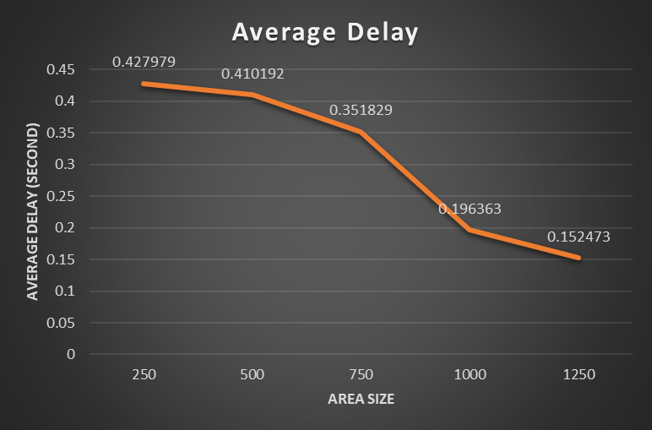

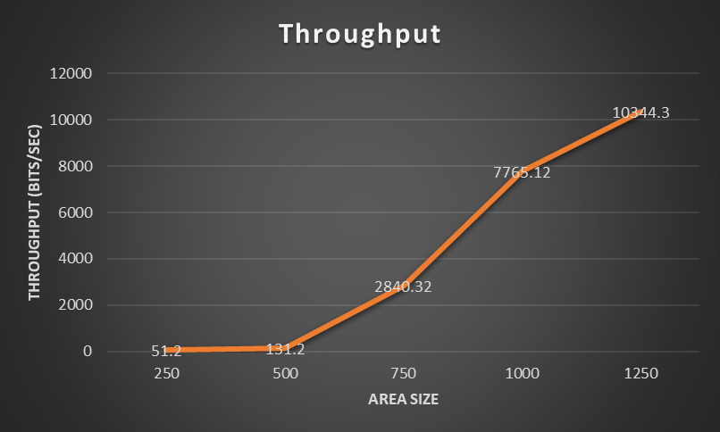

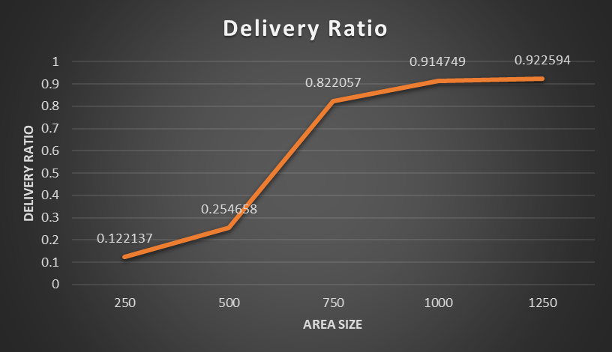

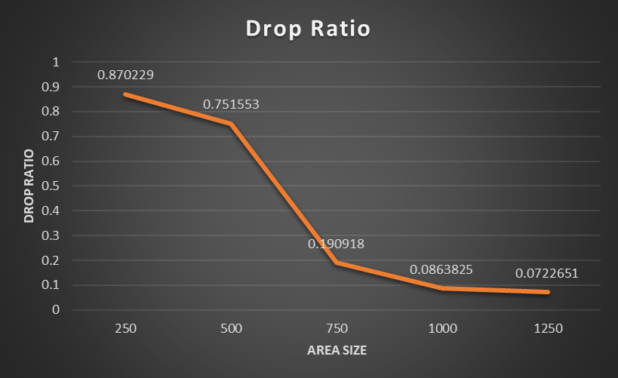

**Varying number of nodes :** (taking 5 samples for each case)

Area Size = 500 and Number of Flows = 20

|  |  |  |  |  |  |  |  |
| --- | --- | --- | --- | --- | --- | --- | --- |
| Number of Nodes | Sent  Packets | Dropped Packets | Received Packets | Throughput  (bits/sec) | Average Delay (sec) | Delivery ratio | Drop ratio |
| 20 | 2281 | 223 | 2069 | 6643.84 | 0.381648 | 0.907058 | 0.0977641 |
| 2118 | 266 | 1854 | 5948.16 | 0.441762 | 0.875354 | 0.12559 |
| 2801 | 241 | 2570 | 8238.72 | 0.226323 | 0.917529 | 0.0860407 |
| 3127 | 281 | 2861 | 9189.76 | 0.311156 | 0.914934 | 0.0898625 |
| 4638 | 187 | 4433 | 14189.4 | 0.194968 | 0.9558 | 0.0403191 |
| 40 | 305 | 189 | 121 | 392.96 | 0.571359 | 0.396721 | 0.619672 |
| 236 | 140 | 101 | 323.2 | 0.454268 | 0.427966 | 0.59322 |
| 395 | 162 | 237 | 764.16 | 0.494436 | 0.6 | 0.410127 |
| 136 | 113 | 23 | 75.52 | 0.596566 | 0.169118 | 0.830882 |
| 328 | 160 | 166 | 531.2 | 0.526335 | 0.506098 | 0.487805 |
| 60 | 253 | 107 | 146 | 467.2 | 0.180577 | 0.577075 | 0.422925 |
| 247 | 146 | 96 | 307.2 | 0.359953 | 0.388664 | 0.591093 |
| 295 | 164 | 134 | 428.8 | 0.465888 | 0.454237 | 0.555932 |
| 284 | 121 | 166 | 535.04 | 0.489624 | 0.584507 | 0.426056 |
| 246 | 152 | 86 | 275.2 | 0.237762 | 0.349593 | 0.617886 |
| 80 | 232 | 160 | 71 | 227.2 | 0.320983 | 0.306034 | 0.689655 |
| 214 | 151 | 64 | 204.8 | 0.401496 | 0.299065 | 0.705607 |
| 139 | 115 | 28 | 92.8 | 0.74858 | 0.201439 | 0.827338 |
| 362 | 208 | 157 | 506.24 | 0.59927 | 0.433702 | 0.574586 |
| 378 | 202 | 178 | 569.6 | 0.502192 | 0.470899 | 0.534392 |
| 100 | 100 | 99 | 3 | 9.6 | 0.823858 | 0.03 | 0.99 |
| 100 | 98 | 3 | 9.6 | 1.43572 | 0.03 | 0.98 |
| 102 | 101 | 2 | 6.4 | 0.467943 | 0.0196078 | 0.990196 |
| 136 | 118 | 19 | 60.8 | 0.323793 | 0.139706 | 0.867647 |
| 246 | 170 | 76 | 243.2 | 0.408775 | 0.308943 | 0.691057 |

**The final data :**

|  |  |  |  |  |  |  |  |
| --- | --- | --- | --- | --- | --- | --- | --- |
| Number of Nodes | Sent  Packets | Dropped Packets | Received Packets | Throughput  (bits/sec) | Average Delay (sec) | Delivery ratio | Drop ratio |
| 20 | 2801 | 241 | 2570 | 8238.72 | 0.226323 | 0.917529 | 0.0860407 |
| 40 | 395 | 162 | 237 | 764.16 | 0.494436 | 0.6 | 0.410127 |
| 60 | 284 | 121 | 166 | 535.04 | 0.489624 | 0.584507 | 0.426056 |
| 80 | 362 | 208 | 157 | 506.24 | 0.59927 | 0.433702 | 0.574586 |
| 100 | 136 | 118 | 19 | 60.8 | 0.323793 | 0.139706 | 0.867647 |

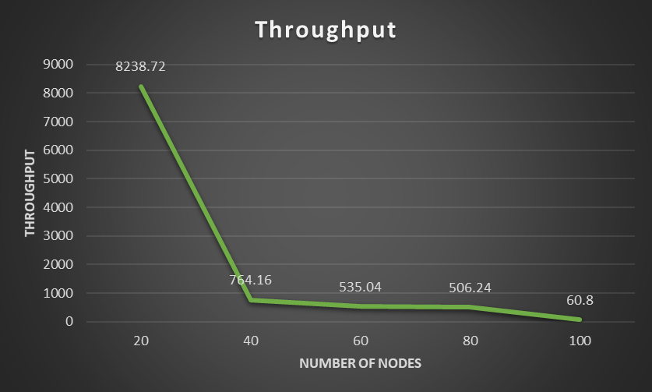

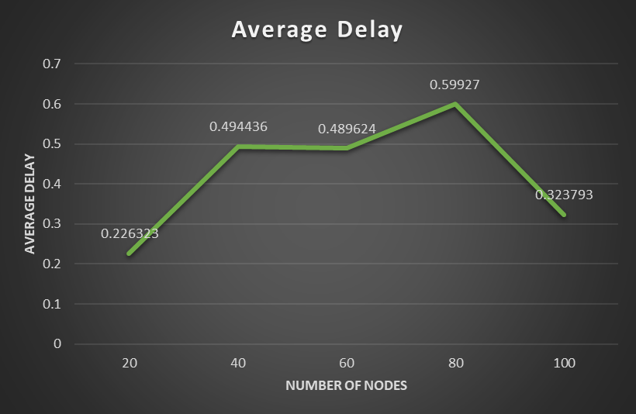

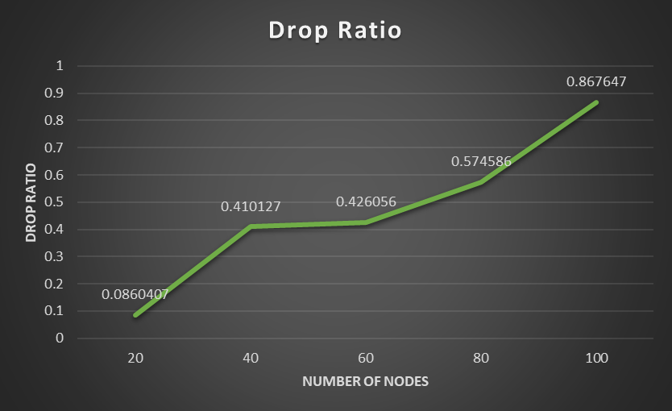

**Varying number of flows :** (taking 5 samples for each case)

Area Size = 500 and Number of Nodes = 40

|  |  |  |  |  |  |  |  |
| --- | --- | --- | --- | --- | --- | --- | --- |
| Number of Flows | Sent  Packets | Dropped Packets | Received Packets | Throughput  (bits/sec) | Average Delay (sec) | Delivery ratio | Drop ratio |
| 10 | 196 | 65 | 137 | 443.52 | 0.307038 | 0.69898 | 0.331633 |
| 643 | 115 | 526 | 1685.12 | 0.308836 | 0.81804 | 0.178849 |
| 425 | 90 | 339 | 1092.48 | 0.268347 | 0.797647 | 0.211765 |
| 493 | 80 | 408 | 1311.36 | 0.238433 | 0.827586 | 0.162272 |
| 138 | 84 | 56 | 181.12 | 0.498217 | 0.405797 | 0.608696 |
| 20 | 287 | 144 | 148 | 478.72 | 0.534818 | 0.515679 | 0.501742 |
| 1039 | 163 | 878 | 2821.12 | 0.256149 | 0.845043 | 0.156882 |
| 330 | 146 | 188 | 601.6 | 0.599641 | 0.569697 | 0.442424 |
| 309 | 179 | 121 | 387.2 | 0.393251 | 0.391586 | 0.579288 |
| 374 | 180 | 198 | 637.44 | 0.56092 | 0.529412 | 0.481283 |
| 30 | 235 | 188 | 48 | 153.6 | 0.536698 | 0.204255 | 0.8 |
| 162 | 158 | 6 | 19.2 | 0.594311 | 0.037037 | 0.975309 |
| 200 | 170 | 30 | 96 | 0.611513 | 0.15 | 0.85 |
| 171 | 154 | 21 | 69.12 | 0.931701 | 0.122807 | 0.900585 |
| 439 | 198 | 239 | 766.72 | 0.724968 | 0.544419 | 0.451025 |
| 40 | 307 | 245 | 61 | 197.12 | 0.535534 | 0.198697 | 0.798046 |
| 200 | 196 | 3 | 9.6 | 1.28325 | 0.015 | 0.98 |
| 223 | 201 | 23 | 75.52 | 1.03311 | 0.103139 | 0.901345 |
| 382 | 260 | 116 | 373.12 | 0.726547 | 0.303665 | 0.680628 |
| 404 | 253 | 147 | 472.32 | 0.881077 | 0.363861 | 0.626238 |
| 50 | 255 | 250 | 6 | 19.2 | 0.815211 | 0.0235294 | 0.980392 |
| 291 | 258 | 34 | 108.8 | 0.96305 | 0.116838 | 0.886598 |
| 250 | 242 | 4 | 12.8 | 1.64873 | 0.016 | 0.968 |
| 259 | 253 | 6 | 19.2 | 0.875356 | 0.023166 | 0.976834 |
| 255 | 248 | 10 | 35.2 | 1.1485 | 0.0392157 | 0.972549 |

**The final data :**

|  |  |  |  |  |  |  |  |
| --- | --- | --- | --- | --- | --- | --- | --- |
| Number of Flows | Sent  Packets | Dropped Packets | Received Packets | Throughput  (bits/sec) | Average Delay (sec) | Delivery ratio | Drop ratio |
| 10 | 643 | 115 | 526 | 1685.12 | 0.308836 | 0.81804 | 0.178849 |
| 20 | 330 | 146 | 188 | 601.6 | 0.599641 | 0.569697 | 0.442424 |
| 30 | 439 | 198 | 239 | 766.72 | 0.724968 | 0.544419 | 0.451025 |
| 40 | 382 | 260 | 116 | 373.12 | 0.726547 | 0.303665 | 0.680628 |
| 50 | 291 | 258 | 34 | 108.8 | 0.96305 | 0.116838 | 0.886598 |

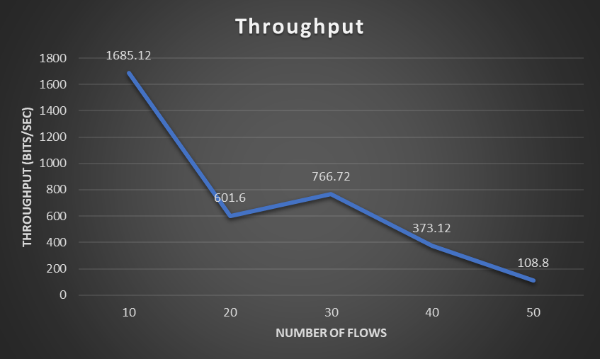

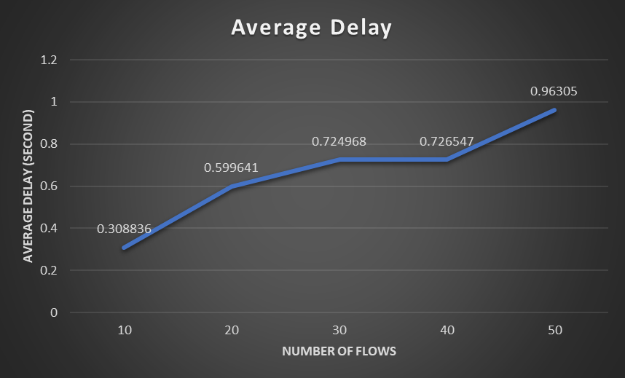

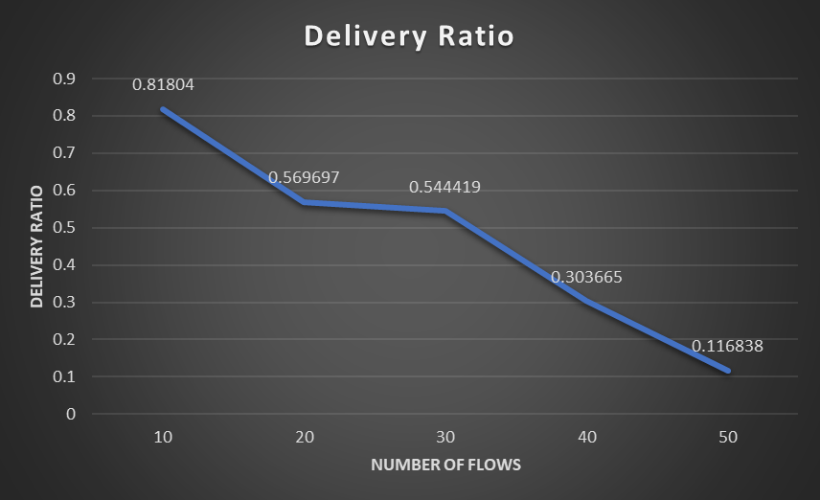

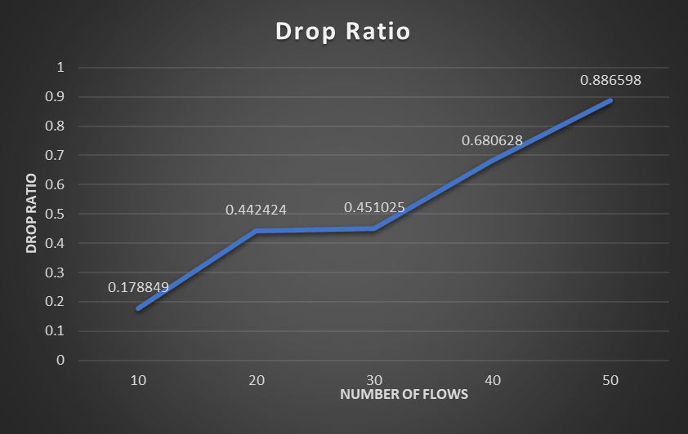

**Observations:**

If we increase area size (keeping number of nodes and flows constant) , node density decreases and so it will be less congested. As a result , we can see from the graphs that with the increase of area size, drop ratio and average delay decreases and on the other hand, throughput and delivery ratio increases.

If we increase number of nodes (keeping number of flows and area size constant) , node density increases and so it will be more congested. As a result , we can see from the graphs that with the increase of number of nodes, drop ratio and average delay increases and on the other hand, throughput and delivery ratio decreases.

If we increase number of flows (keeping number of nodes and area size constant) , it will be more congested and more packets will be stored in queue. As a result , we can see from the graphs that with the increase of number of nodes, drop ratio and average delay increases and on the other hand, throughput and delivery ratio decreases.